Dear Parents and Carers,
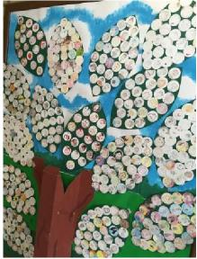 | 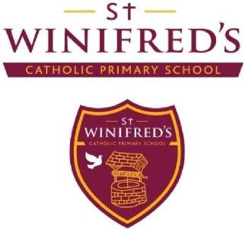 | 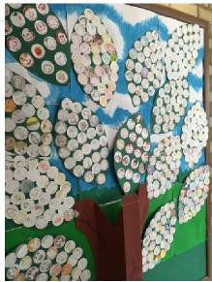
 | Our Achievements 2015/16

This year, our two schools amalgamated to become St Winifred’s Catholic Primary school. We had been working towards this for a long time and it was wonderful to be able to celebrate this great milestone. We had a beautiful service in our church for our whole school community and all of the children had parties in the afternoon and a special commemorative coin.
As we reach the final few days of another very busy school year, we would like to share with you some of the other highlights of this year and achievements which we can all be really proud of.
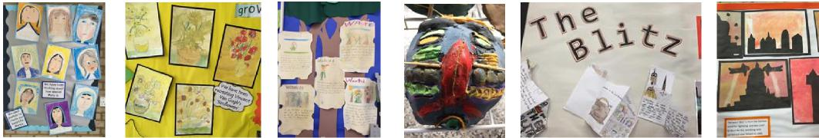
We have supported a number of charities and raised over £1,786 for worthy causes. You donated a really generous amount of food for the Manna Centre and our local food bank at harvest. We also supported Sports Relief and an orphanage in Uganda. At Christmas you donated lots of toys and gifts for the Salvation Army ‘Christmas Appeal’. You have also continued to donate to our Food Bank which supports our school community.
We continued the ‘Roots of Empathy’ initiative in both Year 1 classes. This is a programme which involves a number of visits from a mother and baby throughout the year, to support Personal, Social and Moral development. This has been a wonderful experience which enabled the children to get to know ‘Meela and Campbell’ and to see how they have grown and developed over the year. We will definitely be continuing this programme next year.
We took part in the Year 2 and the Year 5 Maths Zone competitions for Lewisham schools and our teams came first in both. A group of our Year 5 children also took part in an extremely challenging debating competition at Colfes’ School and they got through to the final. Our year 5 and 6 children won the Kwik Cricket competition at Bonus Pastor.
Our swimmers won a large number of medals (including many gold ones) at the schools’ gala earlier this year. Our girls won the runners up Trophy at the Affinity Sutton Football tournament which was held at our school last week. One of our pupils won the Christmas card design competition for the Police Commissioner and was invited to turn on the Christmas lights at Scotland Yard.

Another pupil has gone through to the borough final for her road safety design. She will be presented with a prize next week and her design will be printed on signage around the borough.
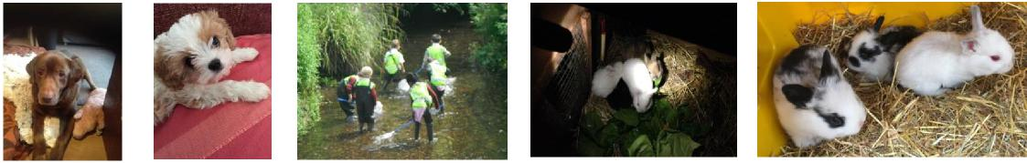
We have had a range of animals living at schools this year including hens, rabbits and guinea pigs at the junior site which have received excellent care from the children. It was really exciting when the baby rabbits were born and the children were able to see them grow and develop. We have had guinea pigs and rabbits in the garden at the infant site.
Year 2 children incubated eggs and watched their chicks hatch, grow and develop. This has been a wonderful learning experience for the children. Lily and Alfie have been frequent visitors at the junior site helping the children to be confident with dogs.
Year 6 classes have had a visit from ‘the Bug Man’ who brought lots of animals and helped the children to consolidate their learning in science.
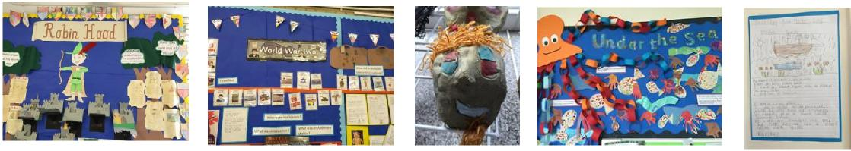
All of the children have been on a range of very exciting educational visits which have really enriched their learning in so many areas and supported our very broad and vibrant curriculum.
These have included visits to the Portrait Gallery, the Museum of London, the Bear Factory, the British Museum, Leeds Castle, the Horniman Museum, the Royal Academy, the Science Museum, the Natural History Museum, the Geffrye Museum, the Golden Hinde, the National portrait Gallery, Brooklyn Bowl, the Royal Academy, Thames Barrier, Pizza Express, the Cable Car, Chislehurst Caves and St Paul’s Cathedral, to name but a few.
All classes visited educational centres including Horton Kirby, Eltham, Soane Centre and Woodland’s Farm, to enable them to learn about living things in the environment and natural features such as rivers. Both Nursery classes went to visit Pets at Home and they went on a wonderful strawberry picking trip. Both of our Reception classes have had six Forest School sessions at Manor House Gardens. We have made many visits to Manor House Library and Park. Children have also visited the Lee Fire Station and Tesco in Lewisham.
They visited Our Lady of Lourdes Church, The Good Shepherd Church and the local Sivan Kovil Temple to learn about places of worship.
The junior children went to the National Theatre and the Unicorn Theatre at Christmas to see ‘Wonderland’ and ‘The Baddies’. Year 2 went to the Unicorn Theatre to see ‘Snow Child’. Year 1, Reception and Nursery
children went to Albany Empire to see ‘The Bear’.
Year 5 children went to Manor House Gardens to sing Christmas Carols for the local community. They also took part in a special mass at Good Shepherd Church this term.
Year 2 and Year 6 took part in the ‘Turning of the Year’ concerts at Blackheath Concert Hall. Year 2, also performed ‘Swinging Samson’ with children from St Margaret’s and St Matthew Academy. Their parents were invited to all of these events.

Our Year 3 pupils went to Eltham College for a series of Art workshops in the summer term.
Year 2 have just returned from a fantastic three day school journey in Gavestone Hall (Sussex), Year 4 went to Carroty Woods for a superb 3 day adventure and Year 6 had a wonderful 5 day adventure with PGL in the Isle of Wight .
Year 5 girls spent a day at St Ursula’s School where they had a taste of technology. Year 6 children went to St Thomas More Secondary School for a very exciting science day. They also spent a day at Goldsmiths learning about University life. Goldsmiths’ students came to school to lead art workshops for Year 5 in the summer term. Year 6 pupils have all been to their new schools to take part in induction days and staff from secondary schools have come to visit the children. All of these experiences have really supported the children in their transition to secondary school.
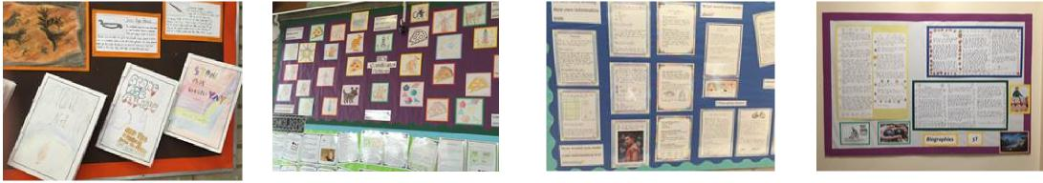
Year 6 children took part in the Junior Citizens programme which taught them all about personal safety.
These educational visits greatly enrich learning for all of the children. We subsidise all visits from money raised by our Friends Association. This year we continued to use public transport as much as possible for educational visits and we have also walked where possible.
Many visitors came to our schools this year to enrich our curriculum provision in all classes.
‘Ten Ten’ drama group led a series of workshops for all the classes in September. The ‘Elevate’ dance company, led Assemblies and workshops at both sites in the spring term. These were based on gospel stories and values and were incredibly powerful and inspirational for the children and staff.
A drama group ran sessions for Year 2 classes to enrich their topic work on Florence Nightingale. The children all gained a great deal from these experiences.
In October, all junior classes took part in performance poetry workshops which inspired them to develop their own pieces.
Quantum Theatre Group performed ‘A Christmas Carol’ at the junior site for our older children and ‘The Elves and the Shoemaker’ for all our younger children at both sites. Quantum performed ‘at the bottom of the Garden’ for all the children on both sites at the end of the spring term. They also performed the ‘Gruffalo’ for all our younger children and ‘The Writing on the Wall’ for our older pupils.
‘Perform’ theatre group came to work with our younger children on a number of occasions throughout the year. The Science Museum outreach team led truly inspirational workshops for all the children from year 1 to 6 on a range of relevant areas of learning in science.
A tree expert came to work with Year 3 pupils on tree identification as part of their science work.
We have worked hard to keep all our children safe and to teach them to keep themselves safe in a range of situations.
We took part in the ‘Kidscape’ anti bullying project this year and many of our classes took part in workshops and assemblies to empower them to deal with bullying. This also involved training for all members of staff. The NSPCC led assemblies for all Key stage 1 and 2 pupils on keeping safe and they led workshops for all year 5 and 6 pupils. We also ran workshops for Year 6 pupils on the subject of ‘Gang culture’.

‘Child net’ also came to the junior site to run sessions for the children on internet safety.
Our Year 4 and 5 pupils took part in First aid training to help them to know how to respond to emergencies. I
would like to extend this to other classes next year.
Officers from the Fire Brigade came in to talk to all pupils in years 2 and 5 about all aspects of fire safety. Our Year 3 and 6 children took part in Bikeability training. This helped many of them to learn to cycle and also to be safe when cycling on the roads. All our classes got to have lots of fun riding all sorts of amazing bikes in the autumn term.
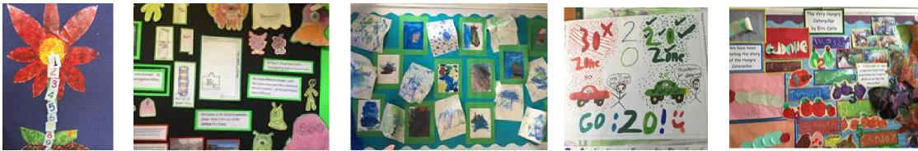
Sustainable transport
We have continued to work really hard to encourage sustainable transport and have submitted our Primary School Travel plan application for Gold accreditation.
Music has had very high profile in our school.
All our year 2 children have had ukulele lessons throughout this year. Junior children have had opportunities to learn to play guitar, flute, violin, drums and brass. This opportunity is taken up by over 100 children each week. Our orchestra have performed two great concerts at the junior site.
Year 5 children took part in the Schools’ Proms at the Albert Hall and our children took part in two ‘Turning of the Year’ concerts at the Blackheath Halls. Pupils in Years 2, 3 and 4 went to see the Bright Sparks concerts at the Festival Hall.
Trinity Laban led an amazing classical music workshop for Years 4 and 5 this year. A ‘Rap’ company came to lead workshops for Year 3 pupils and recorded their creations.
We also held School Book Fairs twice this year and managed to get a very good selection of books for all our classes in both schools.
We had a very special visitor, dressed in red who gave all the children a treat at Christmas.
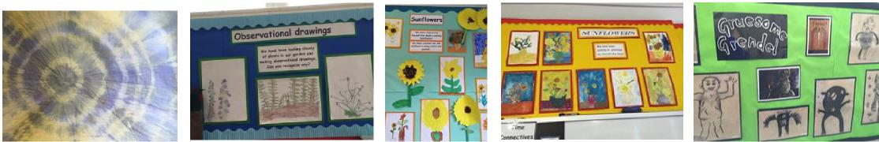
We have had a number of performances and special events in school throughout the year.
All classes took part in Christmas Assemblies (14 in total!) which were wonderful celebrations of achievement. We had Harvest Festival celebrations at both sites. You donated an amazing amount of food for the Manna Centre and for our local food bank. It was lovely to see so many of you at these events.

We have had a number of Masses at the church and at the junior site throughout the year. Each year group from year 2 and above has prepared a service. Year 1 joined us for a number of services and for the first time in many years, our whole school came together at our church to celebrate Our Amalgamation.
We had a beautiful carol service in school at Christmas. We also celebrated Ash Wednesday and had a penitential service at Easter in school. We had a lovely service to celebrate with all our First Communion children and they had a party in the hall in the afternoon. Last week we had a beautiful service in the church for our year 6 leavers.
All of our children dressed up on World Book day and we had storytelling and lots of book related activities in classes.
Six of our musicians performed solos at the Hither Green Festival and astounded the audience.
We had a truly spectacular celebration of the diversity of our school community through our international food and culture afternoon this week. It was wonderful to see so many of our parents and carers enjoying the food and fun.
We are ending the year with a barbecue at the Newstead Road site. This will be organised by our school meals providers and will be a great way to finish our year. We hope to have another one in September for all our families to welcome everyone our new school year.
The pupils in our school have a strong voice and many initiatives and activities which have taken place this year have been as a result of pupil voice.
Pupils from each class have been involved in a range of groups. This has helped them to play an active role in making decisions about the school in order to ensure we hear the voices of the children as we continue to develop. We have a School Learning Council, an Eco Council and a Rights Respecting Group. All Year 1 children take turns being ‘Buddies’ throughout the year and they help others in the playground.
Our Eco Council have been involved in encouraging lots of recycling initiatives: phones, MP3 players, Christmas cards, pens, stamps and batteries. They organised our ‘Clean Plate Day’ and have worked to reduce waste on both sites. These groups have also organised Fruity Fridays at the junior site. A small group from our school council went to talk to the Mayor at the Town Hall in October about issues which caused them concern.
These groups have run a number of assemblies throughout the year which have really inspired the rest of the school.
A group of Year 6 girls organised and ran a talent competition for children in years 2 to 6, earlier in the year and recently a group of Year 4 children ran a competition in their class. Children in Year 5 led an assembly and a charity appeal for an orphanage in Uganda.
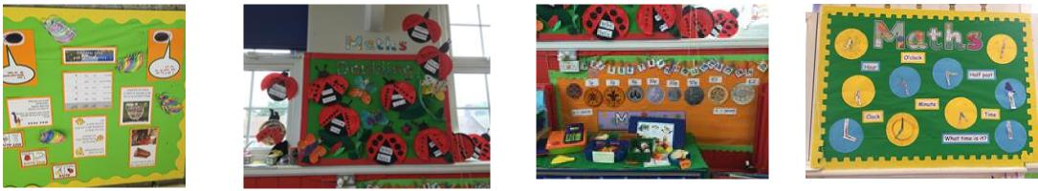
Sport and physical development has had a high profile on both sites this year.
We have used our Sports Funding on both sites, to employ sports play leaders who organised activities every lunch time. These have really engaged the children as well as improving their skills and fitness. We will continue with both of these areas of provision next year.
We hosted girls’ football tournaments at the junior site on two occasions this year. These involved a number of
schools in our local area. It was a privilege to hold these events at our school and one day we hope to win.

We had a ‘Skip to be fit day’ for all our children at the junior site – this really inspired more skipping throughout the school.
The whole school made the most of Sports Relief to improve fitness of all the children as well as to raise money for worthy causes.
Our children have also been taking part in a number of other sporting competitions. Our Year 1, 5 and 6 children have taken part in sporting events and competitions at Bonus Pastor Secondary school.
A number of individuals have taken part in competitions and deserve a special mention. Tobias in Year 6 swam for our school in a number of competitions and won gold in many events. Visnu in Year 5 plays for Kent Cricket Club and Sofia in year 5 is a champion in badminton. Our children play rugby with Old Colfeans and Football for a number of local clubs.
All children from Year 2 and above have had a half term of weekly swimming lessons. Affinity Sutton have led weekly football lessons for our girls in Years 2, 3 and 4.
We had sports events for Nursery and Reception in Manor House Gardens at the end of term and we had sports activities for all the other classes at the junior site. These were organised very capably, by our Year 6 children. They were great fun for all involved.
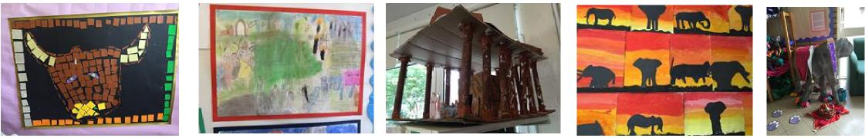
Art and Creativity
We have been working hard to develop art across the school and this year we have taken part in the National Gallery’s ‘Take One Picture’ project. This focused on ‘Roman Triumph’ by ‘Rubens’ and each class created pieces of art in response to this work. Nursery, Reception and Year 1 created instruments and tabards which they played and wore in their carnival procession to open our International afternoon. All other art work was displayed around the Newstead Road site.
Our children at the infant site were asked to contribute art work for the Manor House Garden Festival. This was displayed around the park along with work created by the other local schools.
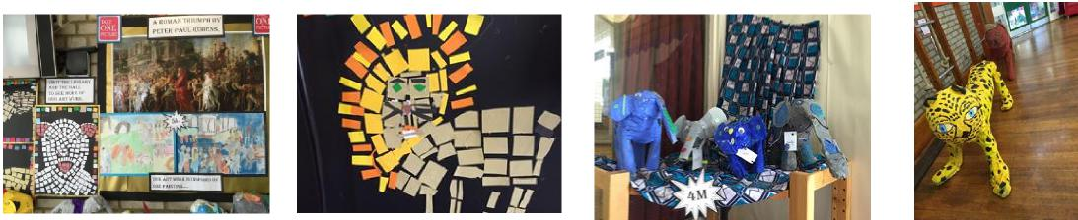
We have involved parents and carers as much as possible in the life of the school.
At the infant site, many parents have been coming to class on Friday mornings to read with their children and this has been a really positive experience for all involved.
Parents and carers have also joined their children for lunch on a number of occasions at the infant site. The children loved eating with their parents and parents found out about school dinners.

We ran a meeting for parents and carers on understanding Dyslexia and another and on Internet safety. Parents and carers were invited to our ‘Ten Ten’ workshop in September and to Masses and many special events throughout the year.
Our annual International Food and Activities Day was an amazing community event which was very well attended by our families and many of our parents helped with organisation and ran activities.
Lots of our parents have been helping classes each week and accompanying on educational visits.
We are extremely privileged to have such tremendous support from our parents and carers in all aspects of school life. This makes a huge difference to the provision in our school and the achievement of our children in all areas of learning.
Breakfast and After-school provision
We have continued to build on our after school clubs and this year we have run: Multi Sports, cricket, diamond football, gymnastics, French, Italian, craft, cheerleading, drama, board games and street dance. We have also run a lunch time club at both sites for children who do not want to be on the playground all the time. We have run football for boys and girls before school at the junior site.
Little Gremlins continue to ensure excellent before and after school provision in our hall for the schools in our local community. They also run clubs throughout the holidays.
Our Friends Association have run a number of extremely successful events for our families including : two discos, an Easter egg hunt at each site, a quiz night, cake sales, a pampering evening, a bingo night, a Mexican Night and a phenomenal Family Fun Day to finish off the year. They raised a large amount of money for our school which has been used to support our rich and vibrant curriculum.
I have received countless positive comments about the children’s behaviour on educational visits and from people who come in to school to work with the children.
And finally, through these rich experiences and a creative and challenging curriculum we have achieved high standards in all subjects in all classes this year.
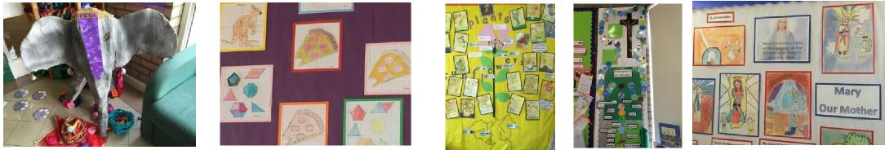
The Future of St Winifred’s Catholic Primary School
Recently our building development plans were agreed and funding agreements have also been signed off. We are expecting our building work to begin at the end of the autumn term and are looking forward to the wonderful opportunities which this will create for our school community. We are particularly looking forward to having all our pupils working together on one site.
Thank you all for the tremendous support which you have given to our school throughout the year.

