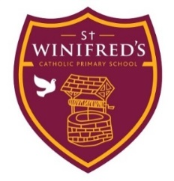

End of Term
Parent / Carer Survey

End of Autumn Term 2022
We are rapidly approaching the end of term and the end and I would really like you to provide me with feedback to two questions.
- What has been going well?
- What could be even better?
I would like as many of you to respond as possible. I am very eager to listen to parent/carer voices. You can either respond via the google form or fill this in and email it back or if hand it in to the school office. You can even remain anonymous if you prefer. By the end of term, I hope to be able to share the responses I have had with you.

Name (Optional) __________________

Year Group(s) of child/ren ____________________

What has been going well?
What could be even better?

