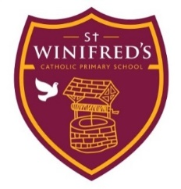

End of Term
Parent Survey

End of Autumn Term 2021
We are rapidly approaching the end of term and the end of my first term as headteacher of St Winifred’s. I have been reflecting on my time here so far and I would really like you to provide me with feedback to two questions.
- What has been going well?
- What could be even better?
I would like as many of you to respond as possible. I am very eager to listen to parent/carer voices. You can email it back or if hand it in to the school office. You can even remain anonymous if you prefer. By the end of term, I hope to be able to share the responses I have had with you.

Name (Optional) __________________

Year Group(s) of child/ren _________________

What has been going well?
What could be even better?

