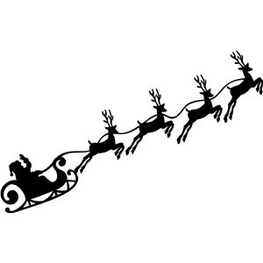
-THE FRIENDS OF ST WINIFRED’S - CHRISTMAS RAFFLE-

Dear parents & carers,

This year, we’re doing things a little bit differently, but we need you more than ever!

The Friends of St Winifred’s are putting together a Christmas Raffle with amazing prizes to be won:
Year Group Hampers, £50 Bar tab @ The Lord Northbrook, £50 voucher @ The Find Store,
Voucher @ Luciano’s, 30 min Family photo shoot @ BB’s Photography + lots more exciting prizes.

We’re asking each child to sell tickets to family, friends, neighbors and even to your colleagues!
The more money we raise, the more we will be able to support the school in improving our children’s education.

You can sell the tickets in the attached sheet. Each ticket is £0.50 – the more they buy, the more chances they get to win!
Please bring this sheet plus money raised in a sealed envelope to your child’s teacher or the school’s office,
latest Thursday 16th December evening.
Raffle will be drawn by the school on the last day of term Friday 17th December.
Thank you for your support,
Your Friends of St Winifred’s association
-THE FRIENDS OF ST WINIFRED’S - CHRISTMAS RAFFLE-
Prizes to be won: Year Group Hampers, £50 Bar tab @ The Lord Northbrook, £50 voucher @ The Find Store,
Voucher @ Luciano’s, 30 min Family photo shoot @ BB’s Photography + lots more exciting prizes.
Please fill in below to enter - £0.50 / ticket – the more you buy, the more chances you get to win!
1  Name:  Phone Number: | 2  Name:  Phone Number: | 3  Name:  Phone Number: | 4  Name:  Phone Number: | 5  Name:  Phone Number:
6  Name:  Phone Number: | 7  Name:  Phone Number: | 8  Name:  Phone Number: | 9  Name:  Phone Number: | 10  Name:  Phone Number:
11  Name:  Phone Number: | 12  Name:  Phone Number: | 13  Name:  Phone Number: | 14  Name:  Phone Number: | 15  Name:  Phone Number:
16  Name:  Phone Number: | 17  Name:  Phone Number: | 18  Name:  Phone Number: | 19  Name:  Phone Number: | 20  Name:  Phone Number:
Raffle will be drawn by the school on the last day of term Friday 17th December.
Child’s name & phone number: Child’s class:

