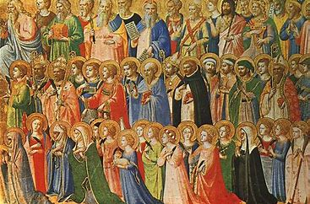
The Month of The Holy Souls
During the month of November, we will remember all those who have died whether it’s family or friends. If you would like us to remember anyone during our class prayer, please complete the sheet and we will keep them in our thoughts.

Name of deceased ……………………………………………………………….

Relationship to you/child ………………………………………………………………………..……………………………………

…………………………………………………………………..…………………………………………

The Month of The Holy Souls
During the month of November, we will remember all those who have died whether it’s family or friends. If you would like us to remember anyone during our class prayer, please complete the sheet and we will keep them in our thoughts.

Name of deceased ……………………………………………………………….

Relationship to you /child …………………………………………………………………..…………………………………………

…………………………………………………………………..……………..…………………………

