**Art/DT**

Sketching skills

Greek pots

**Maths:**

**Number: Place value** - we are looking at larger numbers up to 1 million, rounding, place value, ordering positive and negative numbers on scales and prime numbers.

**Number: Addition and subtraction**

**Statistics**

**Number: Multiplication and division**

**Measurement: perimeter and area**

**Times Tables:** All children should now know all their times tables – but we know that is not the case, so we will continue with times tables tests weekly this term until everyone is secure.

**English:**

We have been reading, ‘Mouse Bird Snake Wolf’ by David Almond, which is a book exploring the themes of creation. Once we have finished this, we will move on to the Odyssey (in translation of course!) which tells the story of Odysseus as he travels back from the Trojan War – he has a very long and eventful journey! We shall focus heavily on grammar this term and getting the children back into their writing. Reading will be taught through the core English texts, short stories and comprehensions but we shall also do lots of 1: 1 reading in class to identify gaps and encourage fluency.

**MFL**

Spanish

**RE:**

We will be following units from ‘The Way, the Truth and the Life’, starting with the story of creation and God’s covenants.

**Autumn Topics**:

**       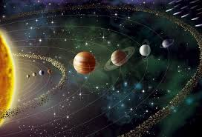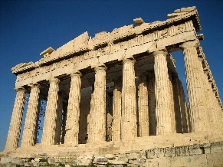                        **

**Science**

**Forces**

* Explain that unsupported objects fall towards the Earth because of the force of gravity acting between the Earth and the falling object
* Identify the effects of air resistance, water resistance and friction, that act between moving surfaces
* Recognise that some mechanisms, including levers, pulleys and gears, allow a smaller force to have a greater effect.

**Earth and Space**

* Describe the movement of the Earth, and other planets, relative to the Sun in the solar system
* Describe the movement of the Moon relative to the Earth
* Describe the Sun, Earth and Moon as approximately spherical bodies
* Use the idea of the Earth’s rotation to explain day and night and the apparent movement of the Sun across the sky

**Earth and Space**

**Forces**

**Ancient Greece**

**PE**

Netball skills and general fitness.

**PSHE:**

We will continue to focus on being kind to each other and in particular on loving each other, as we are ourselves loved by God. The children are learning about ‘zones of regulation’ to help them develop emotional resilience and use strategies when they are in emotional difficulty.

**Music**

Ukuleles

**History**

Greek creation myths and gods and heroes

Empire and slavery

Greek democracy

Women in Greece

Famous battles